Super Micro Computer Inc.

NASDAQ: SMCI Sector: IT Service
Current Price: $579.63 as of 2/2/24
Target Price: $775.00
(33.8% upside)
Recommendation: BUY

Company Overview:
Super Micro Computer Inc. (SMCI in abbreviation) makes total IT solutions for data centers, cloud service providers ("CSPs"), universities, research labs, and any other entity that may require high-end computing solutions. Total IT solutions refers to hardware (server racks or nodes), software, and networking solutions to manage IT systems at scale. SMCI is an engineering-led business with a majority of employees being engineers and an engineer-by-training CEO with numerous patents to his name.
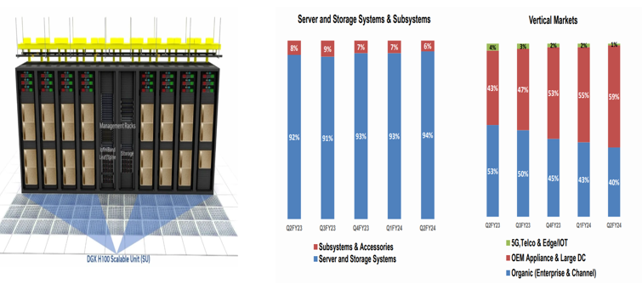
About 90% of the total revenue comes from server/ss and the rest comes from SUBSYSTEM (accessories are less than 10% of the revenue).

OEM (AI cloud services, etc.) is expanding to 60% of buyers, while the existing general enterprise server market is shrinking to 40%.

This is due to the explosive growth of the generative AI service market, and telecommunications service providers (such as UK Nexgen Cloud) that want to provide AI cloud services to generative AI service companies have started placing large orders.

Key Company Statistics
Market Capitalization
$32.74B
52-week Range
80.0-$560.49
Price/Revenue
3.36X
Price/ EBITDA
36.9
Price/Earning
45.3

Industry Overview and Competitive Positioning:
1. The cloud computing market is expected to reach $666.8 Trillion in 2024, a 19%
year-over-year growth.
- The market size of cloud computing will account for 13% of all IT spending, rising to 18% by 2027
- Year 2024 will be characterized by the expansion of IaaS due to the explosive growth of generative AI
- Year 2025 and beyond will be characterized by strong SaaS and BPaaS growth, with an increase in generative AI applications
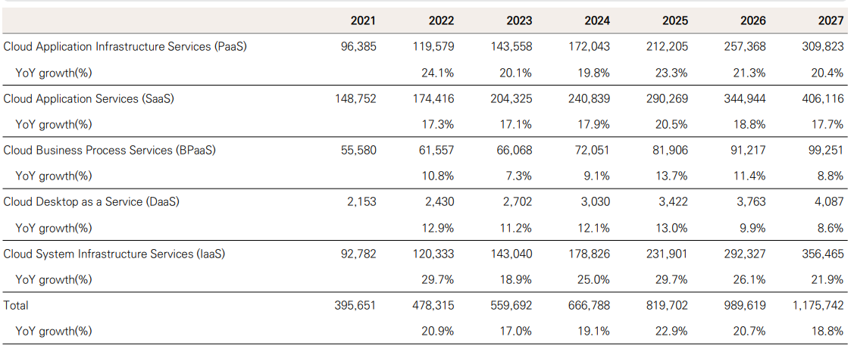
*Sources: Gartner (23.12)

2. Generative AI is expected to grow at a CAGR of 170% through 2027
- Generative AI applications will be applied by industry verticals, with oil and gas and power and utilities having the fastest growth rates.
- Education, insurance, transportation, etc. are also expected to record high growth
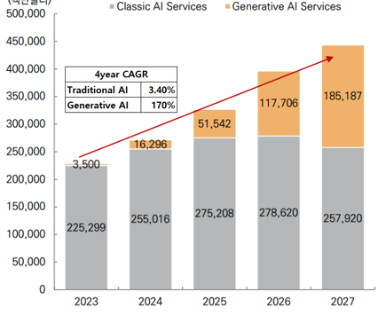
*Source: Gartner(23.10)

3. Positioning: Standing on the shoulders of giants.
- Deep network with Nvidia to benefit 100% from AI data center server market growth
- Intimate network with Nvidia CEO Jensen Huang and AMD CEO Lisa Su
*This network result in SMCI sourcing H100 GPU without any backlog
- H100 GPUs are not readily available to other server manufacturers, but SMCI is. This is why SMCI's growth rate over the past three years has been more than five times higher than other server manufacturers' growth rate
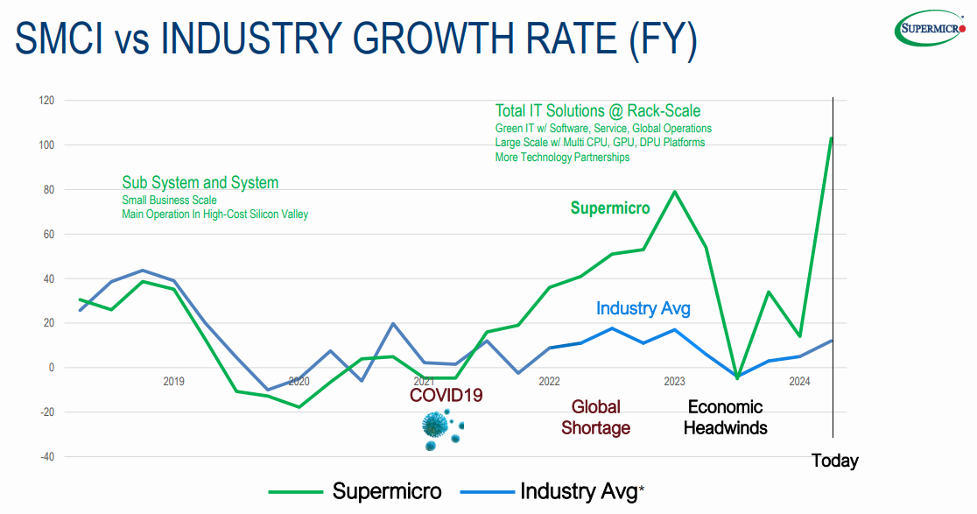

Management: Relationship with Nvidia
CEO Charles Liang (born 1956) is the billionaire co-founder (with his wife Sara Liu), Chairman, President and CEO of Supermicro, an information technology company based in San Jose, California. As of January 2024, Liang's stake in Supermicro is estimated at $3.3 Billion.
Liang was born in Taiwan. He earned a B.S. in Electrical Engineering from the National Taiwan University of Science and Technology, and an M.S. in Electrical Engineering from the University of Texas at Arlington.
His nationality gives him an advantage that other players don't have access to Nvidia (Jensen Hwang) and AMD (Lisa Su), whose CEOs are Taiwanese, a system memory semiconductor manufacturing powerhouse, an advantage that would change the fortunes of Super Micro Computer Inc.
Two companies are working closely together, beginning with a project to integrate Nvidia's AI platform DGX-1 into SMCI's high-performance servers in 2017, followed by the introduction of Nvidia's Hopper GPU architecture-based HGX H100 computing platform into SMCI's AI datacenter in 2022, and the announcement in 2023 that Nvidia will fund SMCI to produce AI chips and jointly develop next-generation AI chips.

Investment Thesis:
SMCI is a Buy with a target price of $750 entailing 33.8% upside taking into consideration the following factors:

Due to the growth of the AI industry triggered by OpenAI (Chat GPT), the investment of generative AI companies is expected to continue
  - AI services from big players like Microsoft's Copilot and Google's Bard continue to launch
- Meta places 150,000 bulk GPU order with Nvidia
- Related AI GPU server market is growing rapidly

In addition to the increase in investment by IT giants currently referred to as Magnificent 7 (Meta, Google, Amazon and etc), growth in the pharmaceutical and bio industry is expected, and the high-speed growth of the AI GPU server market is expected to be maintained for the next 5 years or more
- Nvidia: Continued acquisition of AI-enabled bio drug developers and application of AI technology in bio healthcare expected to continue AI high growth
  - Recently, Jensen Huang saw Bio Healthcare as a new growth driver for Nvidia's AI GPU server market and gave a keynote speech at the JPMorgan Healthcare Conference: "Almost Everything will largely start in silico, largely end in silico.”

  - Significant R&D resources and time were spent on real chemical experiments (in Vitro) and organic material application experiments (in Vivo), but AI GPU (In Silico)s are expected to accelerate the convergence of `AI+Bio' by shifting the way R&D is conducted to reduce costs and time
    - In Vitro: In Glass, medical procedures, tests, and experiments performed outside the organism
    - In Silico: Silicon Chip, simulated on a computer and predictions run on an AI GPU
    - In Vivo: within the living, conducted inside an organism
Investment Summary
- The market for AI GPU servers is booming as the AI service market opens up
- The company is in the very straightforward business of manufacturing and delivering GPU servers to customers
- It's a performance that reminds me of the Levi`s jeans company selling jeans for gold miners during the Western Gold Rush
- Their CEO is from the same country as the chip makers and has deep and long-standing relationships with them
  - The company manufactures DGX servers utilizing Nvidia's H100 chips and delivers them to customers with high-end computing needs
  - As Nvidia's performance increases, the company's performance is directly linked to Nvidia’s growth
- A trajectory similar to Levi`s jeans selling strong jeans durable in mining working condition in the West Gold Rush in the history of United States
  - The company's stock price has risen more than 28 times in five years due to high growth expectations in the AI industry
  - With the application of AI technology to the bio-healthcare industry, AI-related investments are expected to remain the largest CAPEX for SMIC over the next five years

Financial Analysis:
Due to the explosive sales growth, the operating margin/net profit margin and ROE have increased significantly due to the reduction of fixed costs.
1. Sales volume grew by more than 250% compared to 2019 due to the growth of the AI industry, which was stagnant in 2018-2020.
2. Despite the sales growth, net profit grew 10 times more than in 2019 due to the leveraging effect of operating income due to sales growth by maintaining sales margin
3. Rapid profit growth, ROE grows to industry-leading levels.
- SMCI does not currently pay a dividend but is expected to do so in the future due to excess free cash flow
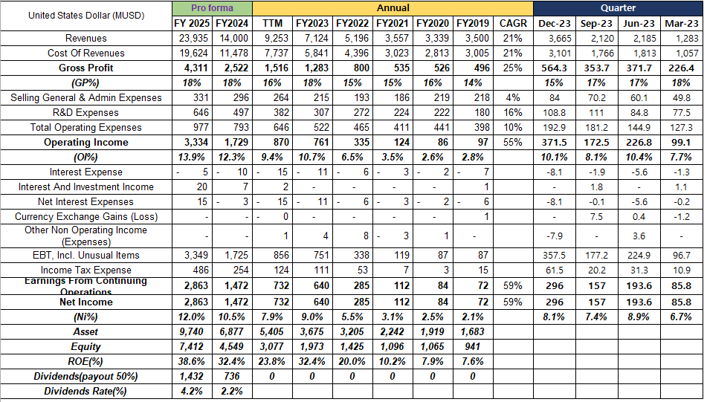

*source: SEC filing 10K,10Q

Valuation:

SMCI's revenue growth is linked to the revenue growth of its key customer Nvidia

(Nvidia Proforma I/S)

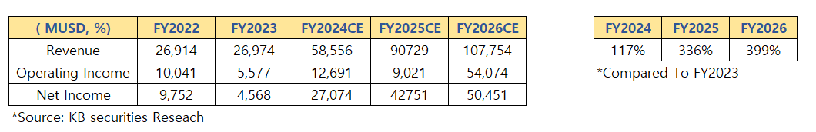

Nvidia's sales are linked to the increase in HBM production by SK Hynix and Samsung Electronics, which are currently experiencing a shortage.

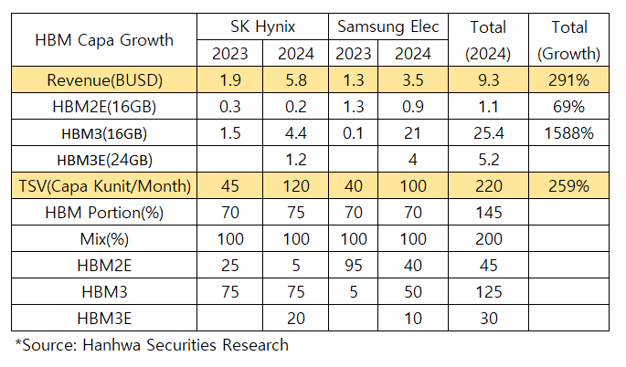

Currently, SMCI’s production capacity is at 65% and 2 additional fabs are expected

to be added.

So it is not difficult to achieve $2.5 Billon in 2025. By June 2024, management expects to

have a production capacity of 1,500 DLC (Direct Liquid Cooling) racks per month and a total

rack capacity of 5,000 rpm.

The San Jose, Netherlands, and Taiwan facilities are operating at a 65% production

utilization rate: they are also adding two new production facilities and warehouses in

Silicon Valley

This increased production capacity will support their new $25 Billion revenue target.

Given the $20 Billion revenue target aligns with 5,000 rpm or 60,000 racks per year, expectation of annual production capacity to increase to roughly 75,000 to make the

$25 Billion revenue goal achievable in the coming years is feasible

SMCI’s sustainable net income comes down to net income in FY2025, and sales in FY2025 is the maximum without additional expansion of production facilities

Conservative assumptions: when applying a perpetual growth model that ends with

FY2025 results, the appropriate discount rate applied to the company is Sofr+100bp (AA grade)

Sales cannot naturally increase beyond year 2025 facility capacity, which it is correct to find the corporate value by calculating the terminal value of DCF: The discount rate applied here is AA level credit rating

The company's Upside Potential based on earnings is 33.7%

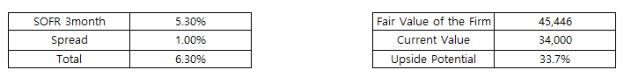

SMCI’s high ROE can be maintained if the GPU server market continues to increase due to the growth of the bio market, and the dividend alone is expected to be similar to that of a term deposit, and the company's stock price level will leap to the next level if SMCI expands additional production facilities. Even though the stock is now up over 5 times in a year, I believe the valuation is supported by the payout and has a margin of safety for further growth in GPUs due to the bio-healthcare sector.
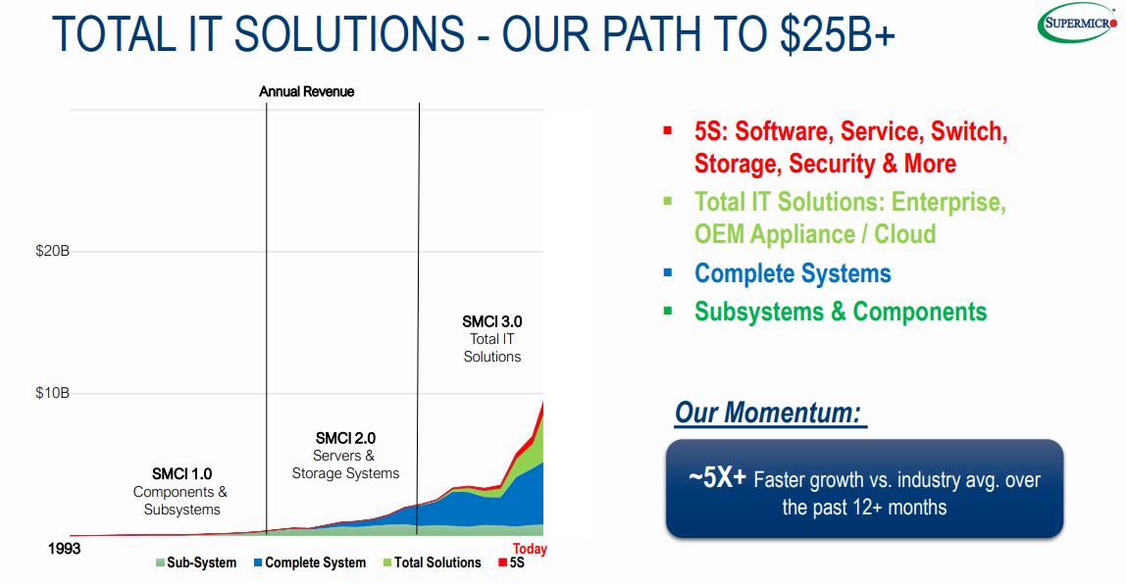

Investment Risks: Excessive dependency on Nvidia

Directly linked to the performance of Nvidia, a key AI beneficiary
SMCI performance will be acutely linked to Nvidia and other leading chipmakers' results. Any negative news as such will materially impact SMCI's stock, even if the news doesn't particularly impact SMCI's core business. While SMCI has been one of the best trades of 2024 so far, such a rapid rise can lead to similarly rapid descents.

If Nvidia loses its leadership in the AI era for some reason, SMCI’s revenue decline is inevitable.

ESG Considerations

SMCI is a simple server manufacturer, and its business activities do not generate carbon emissions.

However, the electricity consumption generated by this AI GPU server is equivalent to the electricity consumption of an entire small country, so I would like to check the technological changes that can affect the ESG perspective of the entire industry rather than SMCI's simple business activities.

1. 43% of computing power is currently used for server cooling, mostly by air-cooling.

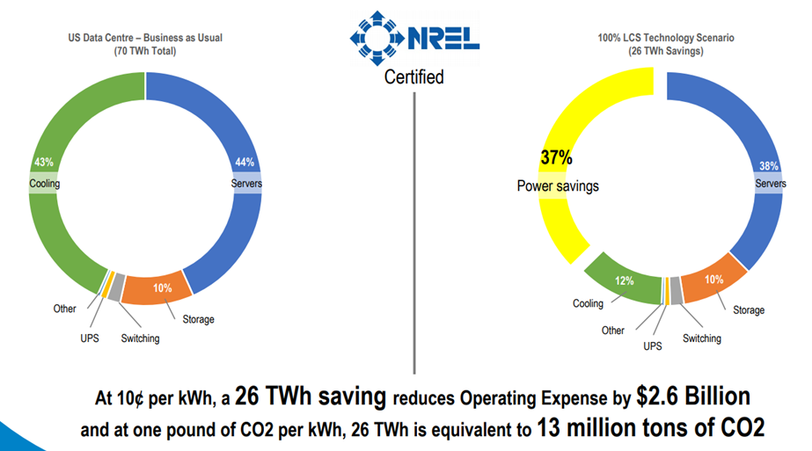
*source: LCS company introduction data

2. The amount of power increases due to the increase in GPU usage, but it is necessary to change the cooling method from the existing air cooling method to liquid cooling, which increases the welfare level of society as a whole by increasing the efficiency of power facilities.

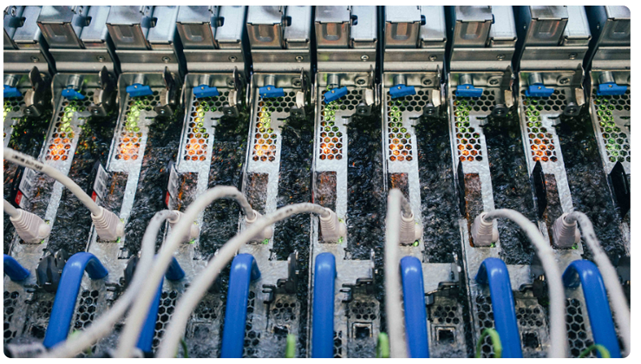

*Boiling Liquid Carries away heat generated by computer servers.(Illustration purpose)
*PUE=Power Usage Effectiveness/ If the power is used to cool the data centre, the PUE number will go up
3. The company is developing technology with a PUE target of 1.05.

The company is striving to reduce total operating costs by more than $10 Billion and save energy
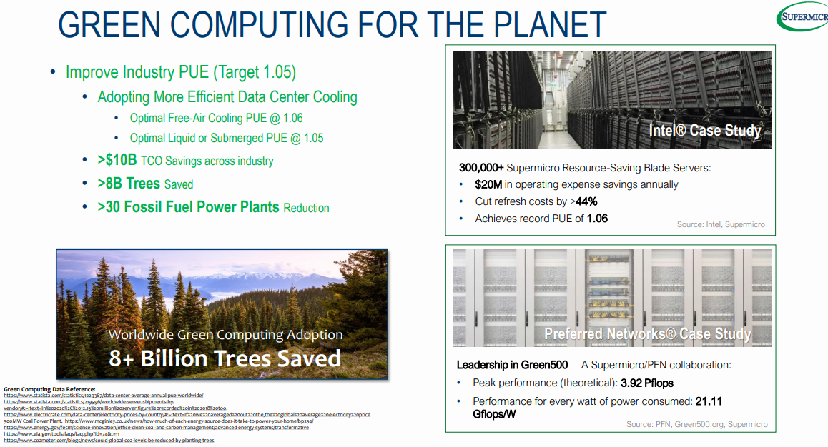

Porter’s Five Forces:

Balanced stock that meets the Porter's 5 Forces criteria
- Customer bargaining power - Low (3 out of 5): There are many server vendors, but few server manufacturers can supply Nvidia's H100 GPU chips in a timely manner
- Competitive Intensity - Low (3 out of 5): Competitive intensity has been high in the general-purpose server space in the past, but in the AI server market, the company has a strong competitive position
- Bargaining power of suppliers - Strong (1 out of 5): Nvidia is the dominant GPU vendor, and the company has to follow Nvidia's pricing policy
- Threat of substitutes - Low (3 out of 5): On-device AI is a substitute, but the capacity for on-device processing is limited compared to AI servers, so I expect a complementary market structure
- Threat from new entrants - Minimal (4 out of 5): I believe that the threat of new entrants is low due to the saturation of the existing market as the server manufacturing technology does not require a specific formula

The Final Word:
Investment gurus have a lot to say about what makes a good company.
I read the books of Philip Fisher, Warren Buffett, and Munger and summarized the points that they all found important and came to the following conclusions.
In addition to the financial analysis, I will conclude my analysis by checking whether the verbs are consistent with the points emphasized by the investment gurus.
- SMCI has a very simple business model, long-standing collaborative relationships with GPU chipmakers, and a high growth rate in the AI industry
- The company is leveraging the same Taiwanese network to dominate the AI server market
- SMCI has made good management decisions to increase ROE through large capital expenditures, rather than resting on its laurels, thereby enhancing shareholder value
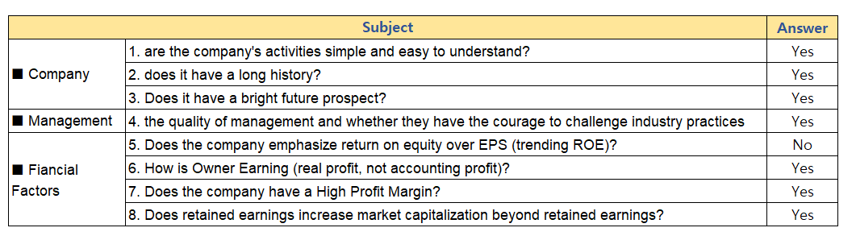

Appendix A: Balance Sheet (In Million)
Subject | TTM | FY2023 | FY2022 | FY2021 | FY2020 | FY2019
Cash & Short Term Investments
Cash And Equivalents | 725.7 | 440.5 | 267.4 | 232.3 | 210.5 | 248.2
Short Term Investments | 0.1 | 0.1 | 0.3 | - | - | -
Total Cash & ST Investments | 725.8 | 440.6 | 267.7 | 232.3 | 210.5 | 248.2
Receivables
Accounts Receivable | 1,503.00 | 1,148.30 | 834.5 | 463.8 | 403.7 | 393.6
Other Receivables | 34.3 | 27.7 | 24.4 | 99.9 | 96.7 | 83.1
Total Receivables | 1,537.30 | 1,176.00 | 858.9 | 563.8 | 500.4 | 476.7
Current Assets
Inventory | 2,467.00 | 1,445.60 | 1,545.60 | 1,041.00 | 851.5 | 670.2
Prepaid Expenses | 112.3 | 117.3 | 134.1 | 6.7 | 7.1 | 7.3
Deferred Tax Assets Current | - | - | - | - | - | -
Restricted Cash | - | - | - | 0.3 | 0.3 | 11.7
Other Current Assets | - | - | - | 23.3 | 23 | 7.8
Total Current Assets | 4,842.40 | 3,179.40 | 2,806.30 | 1,867.30 | 1,592.80 | 1,421.80
Long-Term Assets
Gross Property, Plant & Equipment | 498.8 | 479.6 | 453.7 | 440.6 | 384.3 | 316.1
Accumulated Depreciation | -201.7 | -189.4 | -167.8 | -145.8 | -126.7 | -108.8
Net Property, Plant & Equipment | 297.1 | 290.2 | 286 | 294.8 | 257.6 | 207.3
Long-Term Investments | - | - | - | 6.1 | 4.3 | 4.2
Goodwill | 1.8 | 1.8 | - | - | - | -
Other Intangibles | - | - | - | - | - | -
Deferred Tax Assets | 218.3 | 162.7 | 69.9 | 63.3 | 54.9 | 41.1
Deferred Charges | - | - | - | 5.4 | 4.6 | 3.6
Other Long-Term Assets | 47.3 | 40.6 | 42.9 | 5.1 | 4.5 | 4.6
Total Assets | 5,405.00 | 3,674.70 | 3,205.10 | 2,242.00 | 1,918.60 | 1,682.60

Current Liabilities | TTM | FY2023 | FY2022 | FY2021 | FY2020 | FY2019
Accounts Payable | 1,261.50 | 776.8 | 655.4 | 612.3 | 417.7 | 360.5
Accrued Expenses | 135.4 | 156.1 | 212.4 | 84.6 | 74.8 | 69.6
Short-Term Borrowings | 276.3 | 170.1 | 449.1 | 63.5 | 23.7 | 23.6
Current Portion of LT Debt | 40.8 | - | - | - | - | -
Current Portion of Lease Obligations | 8.9 | 7.8 | - | 6.3 | 6.3 | -
Current Income Taxes Payable | 46.5 | 129.2 | 41.7 | 12.7 | 4.7 | 13
Unearned Revenue, Current | 193.3 | 134.7 | 111.3 | 101.5 | 106.2 | 94.2
Other Current Liabilities | 70.1 | - | - | 87.9 | 74.3 | 45.1
Total Current Liabilities | 1,992.10 | 1,374.70 | 1,470.00 | 968.9 | 707.6 | 606
Long-Term Liabilities | TTM | FY2023 | FY2022 | FY2021 | FY2020 | FY2019
Long-Term Debt | 99.3 | 120.2 | 147.6 | 34.7 | 5.7 | -
Unearned Revenue Non-Current | 190.3 | 169.8 | 122.5 | 100.8 | 97.6 | 109.3
Capital Leases | 16.1 | 11.4 | - | 14.5 | 18.1 | -
Other Non-Current Liabilities | 30.1 | 26.5 | 39.1 | 26.6 | 23.9 | 26.2
Total Liabilities | 2,327.90 | 1,702.60 | 1,779.30 | 1,145.60 | 852.9 | 741.4
Common Equity | TTM | FY2023 | FY2022 | FY2021 | FY2020 | FY2019
Common Stock | 1,190.30 | 538.4 | 481.7 | 438 | 390 | 349.7
Retained Earnings | 1,886.00 | 1,433.00 | 942.9 | 657.8 | 696.2 | 611.9
Treasury Stock | - | - | - | - | -20.5 | -20.5
Comprehensive Income and Other | 0.7 | 0.6 | 0.9 | 0.5 | -0.2 | -0.1
Total Common Equity | 3,076.90 | 1,972.00 | 1,425.60 | 1,096.20 | 1,065.50 | 941

Appendix B: Cash Flow Statement (In millions)
Cash Flow From Operating Activities | TTM | FY2023 | FY2022 | FY2021 | FY2020 | FY2019
Depreciation & Amortization | 36.5 | 34.9 | 32.5 | 28.2 | 28.5 | 24.2
Depreciation & Amortization, Total | 36.5 | 34.9 | 32.5 | 28.2 | 28.5 | 24.2
Stock-Based Compensation | 126.9 | 54.4 | 32.8 | 28.5 | 20.2 | 21.2
Other Operating Activities | -112.6 | -96.3 | -20.2 | -7 | 7 | 16.3
Change In Accounts Receivable | -734.6 | -311.9 | -372.4 | -60.1 | -7 | 85
Change In Inventories | -1,045.20 | 100 | -504.6 | -189.5 | -199.7 | 119.3
Change In Accounts Payable | 697.7 | 127.1 | 50.1 | 189.3 | 59.9 | -173.4
Change In Income Taxes | 7.7 | 87.4 | 29 | 8 | -8.3 | 5.8
Change in Unearned Revenues | 103.6 | 70.6 | 31.5 | -1.5 | 0.4 | 59.8
Change in Other Net Operating Assets | 52.6 | -46.4 | -3.5 | 15.2 | -10 | 20
Cash from Operations | -135.7 | 663.6 | -440.8 | 123 | -30.3 | 262.6
Cash Flow From Investing Activities | TTM | FY2023 | FY2022 | FY2021 | FY2020 | FY2019
Capital Expenditure | -33.5 | -36.8 | -45.2 | -58 | -44.3 | -24.8
Cash Acquisitions | -2.2 | -2.2 | - | - | - | -
Invest. in Marketable & Equity Securt. | -5.7 | -0.5 | -1.1 | - | 0.8 | -
Other Investing Activities | - | - | - | - | - | -
Cash from Investing | -41.4 | -39.5 | -46.3 | -58 | -43.6 | -24.8
Cash Flow From Financing Activities | TTM | FY2023 | FY2022 | FY2021 | FY2020 | FY2019
Short Term Debt Issued | - | - | - | - | - | -
Long-Term Debt Issued | 1,093.90 | 1,093.90 | 1,153.30 | 127.1 | 164.8 | 41.8
Total Debt Issued | 1,807.50 | 1,093.90 | 1,153.30 | 127.1 | 164.8 | 41.8
Short Term Debt Repaid | - | - | - | - | -1.1 | -65.9
Long-Term Debt Repaid | -1,394.40 | -1,394.40 | -640.8 | -60.6 | -159.3 | -68
Total Debt Repaid | -1,606.70 | -1,394.40 | -640.8 | -60.6 | -160.4 | -133.9
Issuance of Common Stock | 607.5 | 30.5 | 21 | 28.4 | 28.3 | -
Repurchase of Common Stock | -208.6 | -178.2 | -10.1 | -138.7 | -8.2 | -3.1
Other Financing Activities | 0 | - | -0.6 | -0.6 | -0.7 | -0.6
Cash from Financing | 599.7 | -448.3 | 522.9 | -44.4 | 23.8 | -95.8
Change In Cash & Equivalents
Foreign Exchange Rate Adjustments | -1.5 | -3.4 | -0.7 | 0.6 | 0.4 | -0.1
Net Change in Cash | 421.1 | 172.4 | 35.1 | 21.1 | -49.8 | 141.8

